

CENTENNIAL COLLEGE PROGRESS CAMPUS

COURSE COMP125 - Winter 2018

|  |  |
| --- | --- |
| Name: Dodam Shin | Student ID: 300960405 |

Please kindly attention to the following instructions:

1. This is an individual test. Zero tolerance policy for any inappropriate behavior (looking anywhere else but your exam sheet).
2. Any talking is not allowed during the exam. Please hand in after finishing the exam and leave the class considering other participants.
3. It is not permitted to use any electronic device (laptop, PC, cell phone, smart watch, calculator) dictionaries, textbooks, class notes and likewise. Use your computer as a typing machine.

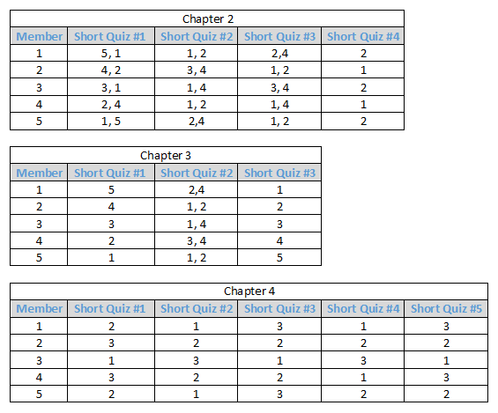

JavaScript, Sixth Edition

Chapter 2 - 2,4 1,2 1,4 1

[SHORT QUIZ]Short Quiz 1

1. What is the difference between a named function and an anonymous function?
2. Why does a named function not execute automatically? How do you execute it?

* You need to call the function with parameter wrapped with parenthesis and it should be end with “;”symbol.

1. What alternatives exist to specifying an event handler using an HTML attribute?
2. How do you view any error messages that a browser might generate when processing your code?

* You can check console pane in the browser (Press F12 in Chrome browser)

1. Why is it poor programming practice to declare a global variable inside of a function by not using the var keyword?

[SHORT QUIZ]Short Quiz 2

[NL]

1. What is the difference between an integer and a floating-point number?

* Integer is 0, negative or positive number without decimal places. Floating-point number may have numbers located in decimal places

1. Which possible values can a Boolean variable have?

* true or false

1. What is an empty string?
2. Why do you sometimes need to insert an extra space in a string when using the concatenation operator?

[SHORT QUIZ]Short Quiz 3

[NL]

1. What is the difference between a binary operator and a unary operator?

* A binary operator needs 2 operands before operator and after operator (ex: x+y)
* A unary operator only needs a single operand which can locate either before operator or after operator (ex: i++)

1. How does JavaScript deal with code that performs arithmetic operations on string values?
2. What is a comparison operator? What kind of value does it return?
3. What is a falsy value? What are the six falsy values in JavaScript?

* NaN, undefined, “”, null, 0,
* It represents false value

[SHORT QUIZ]Short Quiz 4

[NL]

1. When performing operations with operators in the same precedence group, how is the order of precedence determined?

* Basically it goes from left to right
* Multiply (*) and divide (/) operator have priority compared to add (+) and subtract (-) operator

1. How is the expression 5 + 2 * 8 evaluated? Explain your answer.

Chapter 3 - 2 3,4 4

Short Quiz 1

1. How is an array different from a standard variable?
2. How do you create a new empty array?

* var newarrayname=[];

1. How do you access an individual element in an array?
2. What property do you use to determine the number of elements in an array?
3. How do you use a browser to check the value of a specific array element?

Short Quiz 2

1. What is the role of a counter in a repetition statement?
2. What are the differences between a while and do/while statement?
3. Which repetition statement allows you to initialize a counter variable as part of its syntax?

* For loop

1. How do you force a new iteration of a loop even when its condition evaluates to a falsy value?

* Use continue order

Short Quiz 3

* 1. What does an if statement do when its condition evaluates to a falsy value?
  2. What can you do with an if/else statement that you can’t do with an if statement?
  3. Why would you nest decision-making statements?
  4. How do you specify possible values for the expression in a switch statement?

switch (value) {

case value1 : ← possible value that you want to input

statement

break;

.

.

.

default:

statement

break;

}

* 1. What statement should you include at the end of the code for each case label in a switch statement? Why is it important to include this statement?

Chapter 4 Solutions – 3,2,2,1,3

Short Quiz 1

* 1. Explain the difference between syntax errors, run-time errors, and logic errors. Provide an example of each.
  2. Where can you find error messages in a browser?
  3. Suppose your browser console lists a single error, which you find and fix. Why is it important to save your work and reload the page in the browser?
* To make sure you remove the error correctly

Short Quiz 2

1. What are the two different statements you can add to your code to provide you with additional information while you’re debugging?
2. What statement would you use to log the text “itemTotal: ” plus the value of the itemTotal variable to the console?

console.log(“item Total” + itemTotal);

1. When is commenting out code useful in debugging?

Short Quiz 3

1. What is a breakpoint? How do you set a breakpoint?
2. Explain the differences between stepping in (or into), stepping over, and stepping out.

* Stepping in go to every single function and examine every line of code.
* Stepping over go to every function as well, but don’t examine every line. So in console panel, it highlights the beginning of each function.
* Stepping out escapes the codes that debugging tool currently examine. When you think the function works correctly and doesn’t have any bugs, you can use it.

1. What is the call stack? How do you use it in debugging?

Short Quiz 4

1. When is it necessary to include exception handling in your code? Give an example.

* ??

1. What statement in the code to handle an exception do you use to specify an error message?
2. How do you reference a previously generated error message in a catch() statement?

Short Quiz 5

1. How can code editors designed for web development help you in identifying errors in your HTML?
2. What code would you enter on the command line to declare a variable named [BEG CODE]cost[END CODE] with a value of 75, and then log to the console the result of multiplying the cost variable by 1.2?
3. Explain how coding in strict mode can help you write better code.

* In strict mode, you can reduce a chance of producing bugs and errors. Without flexibility, you should clearly define each function, method and variable